Jack Aldworth

10/31/2024

Evolutionary Robotics

Project #6: Dynamic Recurrent Neural Networks

**Part 1: Designing the Body**

I decided to go for option one of the two paths we could take for this project and combine a dynamic model to a neural network. To do this I first had to make a model to combine the neural network with. I decided to go for a traditional four-legged creature model, with one large abdomen and four joints (fig. 1).

Figure : Model of Body

I decided to use this model due to the fact that I already knew a few ways in which a creature like this could possibly move and could easily manually program its movement if the need arose.

**Part 2: Choosing a Neural Network**

Of the three models provided I chose to go with the CTRNN as it seemed to be the most interesting network to model, and the one in which I could most easily see how the network reacted to its environment. You can find the code I used to generate the body, and run the neural network here:

**Part 3: Connecting the Model to the Neural Network**

I decided to connect the neural network to the model by adding a motor to each joint of the model, and having the motors angle, set to the output of the neural network. The inputs to the neural network are the X, Y, and Z positions of the model itself, and the time passed in the model so far.

I determined the goal of the model, to be to move as far in the X direction as it possibly could in the given time. By setting the weights and biases randomly I ended with quite a few interesting behaviors, but no model managed to do anything more than jump once. A couple of these models actually began to make a little bit of progress in moving forward (figs. 2-3).

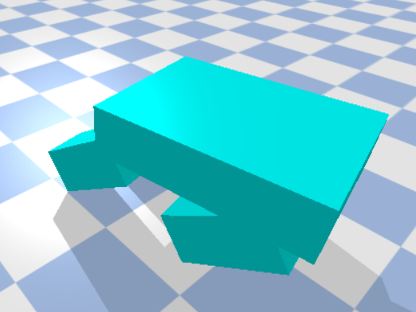

Figure : "Jumping" Model 1 Figure 3: “Jumping Model 2

Below is the activity map and neural state activity map of both the above runs (figs. 4-7). I is intresting to note how different the neural network is behind the scenes, compared to how similar the the actons the two runs took.

Figure 4: Model 1 Output Activity Figure 5: Model 2 Output Activity

Figure 6: Model 1 Neural State Activity Figure 7: Model 2 Neural State Activity

**Part 4: Potential Future Work**

Based on what I’ve done for this project, I would consider using a dynamic model for my final project, but I likely will not use a dynamic recurrent neural network. This is because while interesting to look at and mathematically intriguing I do not feel like I have a very good understanding of how to apply such a model to a problem without using back propagation, defeating the point of using evolutionary neural networks. If I had more access to resources related to evolving the networks rather than just the functions of the network themselves I would be more tempted to experiment with them, but at the moment they just leave me more confused than interested.